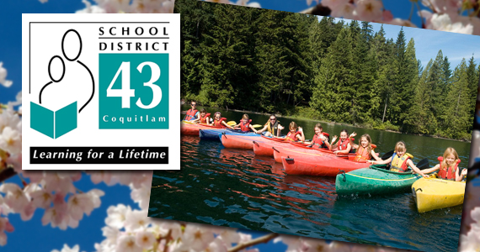

Grade 5 Camp fundraising is underway. Our bake sale at the Book Fair was a success! Thanks to all for sending your baking and those who sold the goodies. We raised $259.

Mr. Peters has sent out information on our current fundraiser of Purdy Chocolate Suckers. Thank you to the Firth family for organizing this event. Money is due date no later than December 9th. Happy selling!
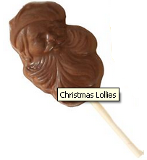

January we will be fundraising with Meridian Meats stay tuned for more information.

February 14th at CRE’s movie night, the Grade 5’s can sell candy bags and have a raffle table. If you have any items to donate to our raffle table please bring them to your child’s classroom labelled “Raffle Draw”. We will need parent and student volunteers to sell raffle tickets and candy bags. We will send home a sign up sheet in January for volunteers.

February we will be fundraising with our bottle drive stay tuned for more information. Please let your neighbours know about our upcoming bottle drive so they can save their holiday empty bottles for us. If you have bottles you need to get rid of before the bottle drive, please take them to the Biggar Bottle Depot on 2577 Kingsway Ave, Port Coquitlam. Please ask for the money from the bottles to be put into the Coquitlam River Elementary Grade 5 Camp account.
Thank you to Tracey McConnell for setting up an account for us.

We have a parent considering putting a slide show together for the Grade 5 Grad Ceremony. We are just waiting for confirmation. If any other parents would like to be involved please let us know by email: ksyrnyk@hotmail.com

We have a team of parents who have volunteered to organize a year book for the Grade 5’s. We need your help! Please send to this drop box http://dbinbox.com/cregrad14 code grade5grad your photos of the Grade 5’s. Thank you to John & Melanie Rogers for setting up the drop box. So far this year we have had the Terry Fox Run, Halloween, Star Assembly, Remembrance Day, Choir, and Volleyball. We need your pictures so keep them coming. We will be designing a 28 page(14 sheets double sided) hard cover book. As a tradition every grade 5 graduating class before us has purchased year books for the grade 5 teachers and principal. We negotiated a reasonable price on the books. The cost of the books for the teachers and principal will be added to the cost of your child’s book cost. The cost of the year book is $31 each including taxes.
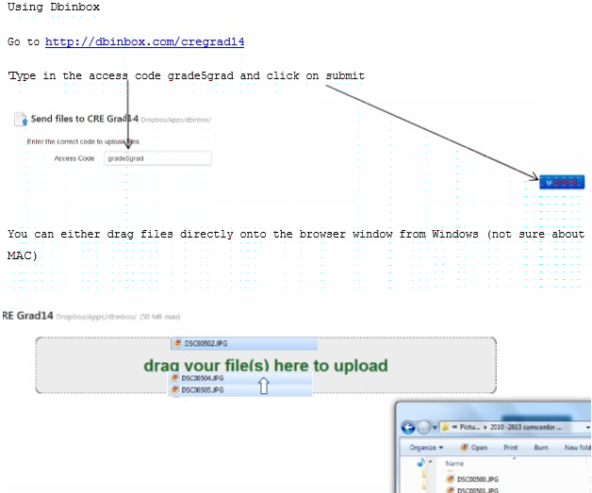
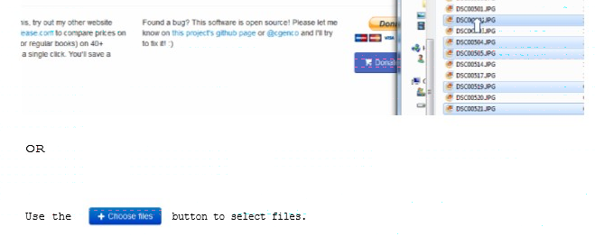

F.Y.I.I tried to upload pictures to our drop box and I’m happy to say it was very simple. But if for some reason you need assistance please do not hesitate to ask for help. Karen Syrnyk

